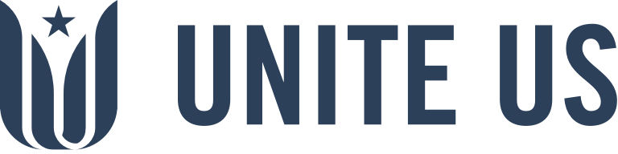**Press Release**

_____________________________________________________________________

**VMAP Expands Partnership with Unite Us to Strengthen Perinatal Mental Health Across Virginia**

*New initiative empowers healthcare providers to seamlessly connect pregnant and postpartum patients with life-saving behavioral health and social services.*

**RICHMOND, VA – September 22, 2025** – The Virginia Mental Health Access Program (VMAP) today announced the expansion of its strategic partnership with [Unite Us](http://www.uniteus.com), the nation’s trusted technology partner for integrating health and community-based care, to amplify its [VMAP for Moms+](https://vmap.org/vmap-for-moms/) initiative. The new program is designed to address the growing crisis in perinatal mental health by equipping healthcare providers with the tools and support needed to better serve pregnant and postpartum patients across the Commonwealth.

Building on VMAP's established success improving pediatric mental health, the *Moms+* program will streamline referrals, track care coordination, and expand access to essential services for families in need through the Unite Virginia network.

Perinatal mental health conditions are the leading cause of maternal mortality in the U.S.; [According to VMAP](https://vmapformoms.org/), 75% of patients who report mental health concerns during pregnancy and postpartum go untreated. Without timely care, these conditions can lead to serious consequences like preterm birth, poor parent-infant bonding, and long-term developmental challenges.

The *VMAP for Moms+* initiative sets out to tackle this crisis by empowering Virginia healthcare providers—including OB/GYNs, midwives, pediatricians, and others—with the tools to proactively meet patients’ needs. Using Unite Us’ closed-loop referral system, providers can seamlessly connect patients and their children to appropriate behavioral health services and community-based resources in their local communities, helping patients receive the comprehensive care they deserve.

“The expansion of VMAP services through Moms+ is a vital step in ensuring pregnant and postpartum individuals receive timely mental health support,” said Ally Singer Wright, Senior Director for VMAP. “By partnering with Unite Us, we are making it easier than ever for providers to connect their pregnant or postpartum patients with the care they need quickly and securely, often directly through their electronic health record. This partnership removes barriers and streamlines access to critical perinatal and social support services.”

Unite Virginia is a robust network of more than 10,850+ healthcare providers, government agencies, and community-based non-profits, all committed to improving whole-person care for Virginians. By tapping into this network, VMAP can ensure patients receive referrals not only for behavioral health services but also for essential supports such as transportation, food assistance, substance use treatment, and parenting resources—factors directly tied to improved maternal health outcomes.

“Unite Us is proud to deepen our partnership with VMAP as they expand services to address the pressing issue of maternal mental health in Virginia,” said Meredith Little, Senior Director for the Virginia Network at Unite Us. “This collaboration creates a more connected care environment for families during a critical period in their lives and ensures providers have the tools they need to deliver holistic, compassionate care.”

This unique partnership positions VMAP for Moms+ to have a far-reaching impact on maternal and infant health outcomes across Virginia. Providers will have quick and easy access to a robust network of behavioral health and social care services, ensuring patients receive the comprehensive support they need at one of the most vulnerable times of their lives.

All non-profit community-based organizations can access Unite Us’ platform free of charge. Contact us to learn more at uniteus.com/contact/.

**About VMAP for Moms+**

VMAP for Moms+ is a perinatal expansion of the Virginia Mental Health Access Program (VMAP), focused on improving access to mental health services for pregnant and postpartum individuals and their children. The program offers free psychiatric consultation, resource navigation, and provider education to health professionals across Virginia. For more information, visit www.vmap.org.

**About Unite Us**

Founded in 2013 by Military Veterans, Unite Us is the nation’s premier technology provider for integrating health and community-based care. Our advanced product suite is used to proactively coordinate services using data-driven insights, streamline referral and case management, and facilitate eligibility assessments and reimbursements across government, healthcare, health plans, and community organizations. The first of its kind, our closed-loop referral system prioritizes privacy and dignity and has integrated data and analytics tools used to measure impact, optimize programs, and shape policy. With over 1.7M services, we host the nation’s largest network of community-based health and economic services dedicated to improving whole-person health. Learn more at [UniteUs.com](http://uniteus.com) and [LinkedIn](https://www.linkedin.com/company/uniteus).

**Media Contacts:**

Ally Singer Wright

Senior Director, VMAP

info@vmap.org

Communications@uniteus.com